Step 1 : Install React query

npm add react-query

Step 2 : Import package at the top

import { QueryClientProvider, QueryClient} from 'react-query'

Step 3 : Create object in App.js before function

//step 2:  Create object

const queryClient= new QueryClient()

Step 4 : Wrap App.js code into QueryClientProvider

 <QueryClientProvider client={queryClient}>

App.js Code :

import { QueryClientProvider, QueryClient} from 'react-query'

import {BrowserRouter as Router, Route, Link, Routes } from 'react-router-dom';

import './App.css';

import { HomePage } from './components/Home.page'

import { RQSuperHeroesPage } from './components/RQSuperHeroes.page'

import { SuperHeroesPage } from './components/SuperHeroes.page'

//step 2:  Create object

const queryClient= new QueryClient()

function App() {

  return (

    // step 2 : Wrap into queryClientProvider

    <QueryClientProvider client={queryClient}>

      <Router>

        <div>

          <nav>

            <ul>

              <li>

                <Link to='/'>Home</Link>

              </li>

              <li>

                <Link to='/super-heroes'>Traditional Super Heroes</Link>

              </li>

              <li>

                <Link to='/rq-super-heroes'>RQ Super Heroes</Link>

              </li>

            </ul>

          </nav>

<Routes>

            <Route path='/super-heroes' element={<SuperHeroesPage/>} />

            <Route path='/rq-super-heroes' element={<RQSuperHeroesPage/>} />

            <Route path='/' element={<HomePage/>} />

          </Routes>

        </div>

      </Router>

      </QueryClientProvider>

  )

}

export default App;

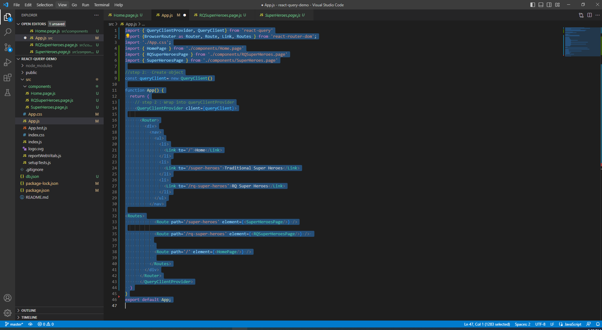

Step 5 : install axios

npm add axios

Step 6 : Import the

import { useQuery } from 'react-query'

import axios from 'axios'

Add code :

import React from 'react'

import { useQuery } from 'react-query'

import axios from 'axios'

export const RQSuperHeroesPage = () => {

  const{isLoading, data}=useQuery('rqsuper-heroes',()=>{

    return axios.get('http://localhost:4000/superheroes')

  })

    if(isLoading){

      return <h2>Loading......</h2>

    }

      return (

        <div>

          RQSuperHero Page

          {data?.data.map((hero)=>{

            return <div key={hero.name}>{hero.name}</div>

          })}

        </div>

      )

    }

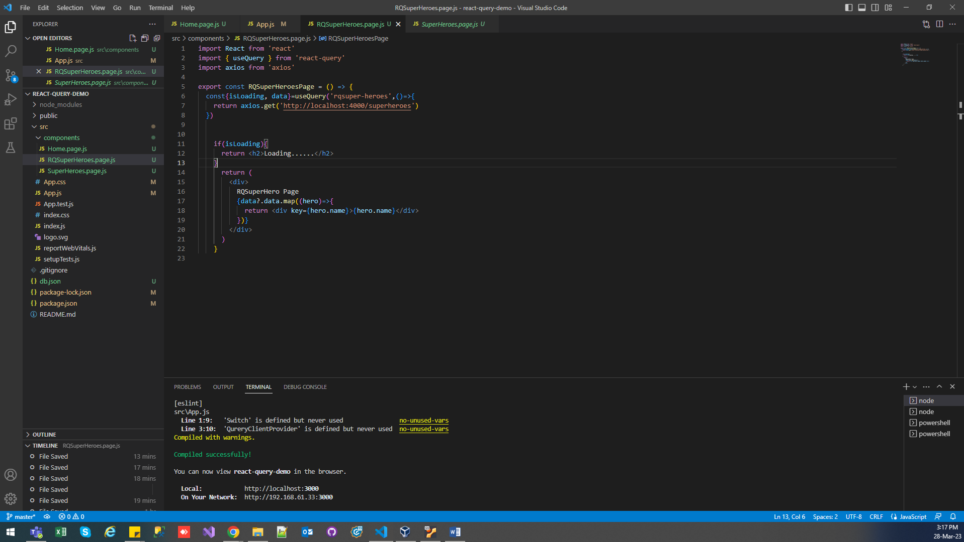

Output :

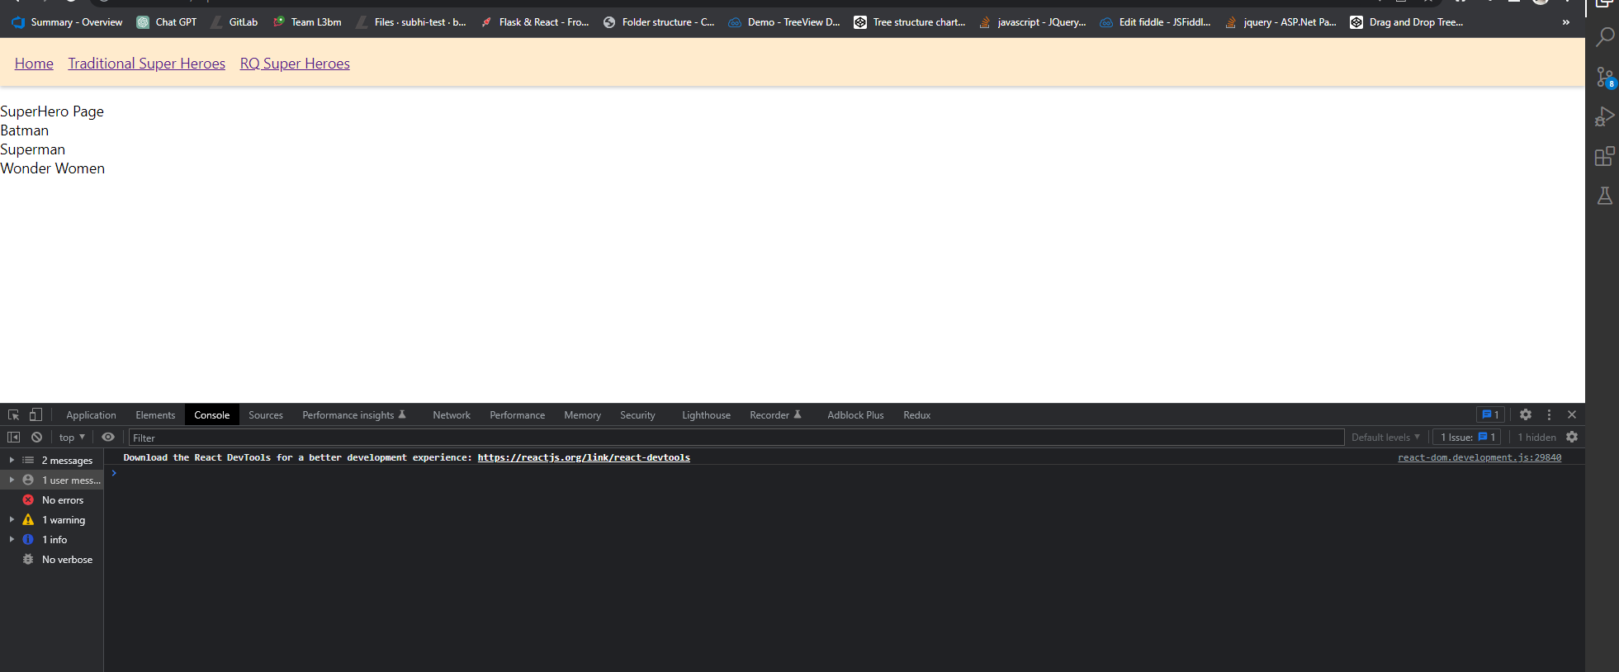

Extract Code little bit :

import React from 'react'

import { useQuery } from 'react-query'

import axios from 'axios'

const fetchData=()=>{

  return axios.get('http://localhost:4000/superheroes')

}

export const RQSuperHeroesPage = () => {

  const{isLoading, data}=useQuery('rqsuper-heroes',fetchData)

    if(isLoading){

      return <h2>Loading......</h2>

    }

      return (

        <div>

          RQSuperHero Page

          {data?.data.map((hero)=>{

            return <div key={hero.name}>{hero.name}</div>

          })}

        </div>

      )

    }

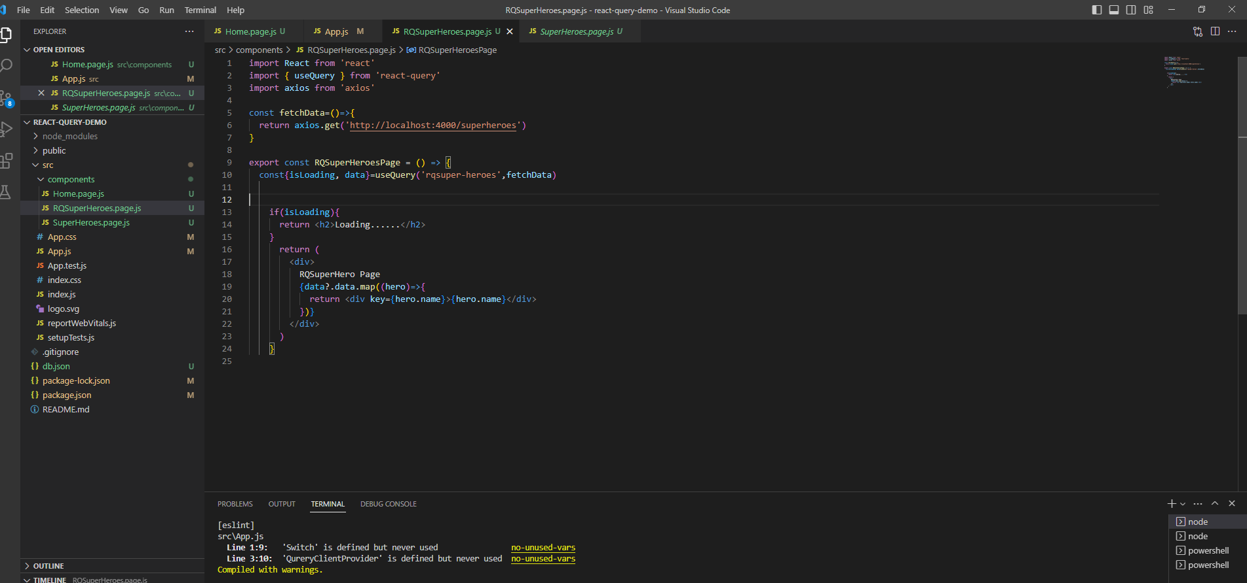

----------------------------------------------------------------End--------------------------------------------------------------------

Simple Way to fetch data without useQuery :

import React from 'react'

import { useState,useEffect } from 'react'

import axios from 'axios'

export const SuperHeroesPage = () => {

  const [isLoading,setIsLoading]=useState(true)

  const [data,setData]=useState([])

  useEffect(()=>{

  axios.get('http://localhost:4000/superheroes').then((res)=>{

    setData(res.data)

    setIsLoading(false)

  })},[])

  if(isLoading){

    return <h2>Loading......</h2>

  }

    return (

      <div>

        SuperHero Page

        {data.map((hero)=>{

          return <div key={hero.name}>{hero.name}</div>

        })}

      </div>

    )

  }